Experiment No. 1
Student Name: Ojaswini Thote
PRN: 24070521048
File Path: file:///Users/ojaswinithote/Desktop/Javascript/EXP%201/index1.html

Experiment Title
Demonstration of Inline, Internal and External JavaScript, Console Methods and Student Information Webpage

Software / Tools Required
- Visual Studio Code
- Google Chrome
- HTML5
- CSS3
- JavaScript (ES6)

Experiment Program Code

index.html — Department Home Page
<!DOCTYPE html>
<html>
<head>
<title>Welcome to SIT!</title>
<style>
body{
font-family: Arial, sans-serif;
background-color: lightpink;
}
.box{
width: 450px;
margin: 30px auto;
padding: 20px;
border: 2px solid black;
border-radius: 10px;
background-color: white;
}
h1, h2{
text-align: center;
}
input[type="text"],
input[type="number"],
select{
width: 100%;
padding: 5px;
margin-top: 5px;
margin-bottom: 10px;
box-sizing: border-box;
}
button{
padding: 8px 15px;
background-color: blue;
color: white;
border: none;
cursor: pointer;
}
button:hover{
background-color: darkblue;
}
#output{
margin-top: 20px;
padding: 10px;
border: 1px solid black;
background-color: #f8f8f8;
}
</style>
<!-- Internal JavaScript -->
<script>
function showWelcome() {
let name = document.getElementById("name").value;
let age = document.getElementById("age").value;
let cgpa = document.getElementById("cgpa").value;
let email = document.getElementById("email").value;
let phone = document.getElementById("phone").value;
// Get selected semester
let semester = document.querySelector('input[name="semester"]:checked').value;
// Get selected section
let section = document.getElementById("section").value;
document.getElementById("output").innerHTML =
"<h2>Student Information</h2>" +
"<p><b>Name:</b> " + name + "</p>" +
"<p><b>Age:</b> " + age + "</p>" +
"<p><b>CGPA:</b> " + cgpa + "</p>" +
"<p><b>Semester:</b> " + semester + "</p>" +
"<p><b>Section:</b> " + section + "</p>" +
"<p><b>Email:</b> " + email + "</p>" +
"<p><b>Phone Number:</b> " + phone + "</p>";
console.log("Name: " + name);
console.info("Age: " + age);
console.log("CGPA: " + cgpa);
console.log("Semester: " + semester);
console.log("Section: " + section);
console.log("Email: " + email);
console.log("Phone: " + phone);
console.warn("This is a warning message");
console.error("This is an error message");
}
</script>
</head>
<body>
<div class="box">
<h1>Welcome to SIT!</h1>
<h2>Student Information</h2>
<label>Enter Name:</label><br>
<input type="text" id="name" placeholder="Enter Name"><br>
<label>Enter Age:</label><br>
<input type="number" id="age" placeholder="Enter Age"><br>
<label>Enter CGPA:</label><br>
<input type="text" id="cgpa" placeholder="Enter CGPA"><br>
<label>Select Semester:</label><br>
<input type="radio" name="semester" value="Semester 1" checked> Semester 1<br>
<input type="radio" name="semester" value="Semester 2"> Semester 2<br>
<input type="radio" name="semester" value="Semester 3"> Semester 3<br>
<input type="radio" name="semester" value="Semester 4"> Semester 4<br>
<input type="radio" name="semester" value="Semester 5"> Semester 5<br>
<input type="radio" name="semester" value="Semester 6"> Semester 6<br>
<input type="radio" name="semester" value="Semester 7"> Semester 7<br>
<input type="radio" name="semester" value="Semester 8"> Semester 8<br><br>
<label>Select Section:</label><br>
<select id="section">
<option value="Section A">Section A</option>
<option value="Section B">Section B</option>
<option value="Section C">Section C</option>
<option value="Section D">Section D</option>
</select>
<label>Enter Email ID:</label><br>
<input type="text" id="email" placeholder="Enter Email"><br>
<label>Enter Phone Number:</label><br>
<input type="number" id="phone" placeholder="Enter Phone Number"><br><br>
<button onclick="showWelcome(); greet();">
Submit
</button>
<hr>
<div id="output"></div>
</div>
<script src="script.js"></script>
</body>
</html>
Description:
- Displays the department homepage.
- Contains navigation to the Student Information page.
- Uses an external JavaScript file (script.js) for alert messages and console methods.

script.js — External JavaScript
function greet() {
alert("Welcome to SIT, Nagpur!");
console.table([
{
Name: "Sample User",
Course: "JavaScript"
}
]);
console.time("Execution");
console.timeEnd("Execution");
}
Description:
- Defines the greet() function.
- Displays a welcome alert.
- Demonstrates JavaScript console methods: console.table(), console.time(), and console.timeEnd().

website.html — Student Information Page (Internal + Inline JavaScript)
Description:
- Accepts student name and age.
- Validates user input.
- Generates a dynamic student details table.
- Uses Internal JavaScript for form validation and table generation.
- Uses Inline JavaScript through the button's onclick event.
- Uses External JavaScript by calling greet() from script.js.

Output
- The department homepage loads successfully.
- Clicking View Student Info Page opens the student information form.
- A welcome alert is displayed.
- Student information is shown in a formatted table.
- Browser console displays console.log(), console.info(), console.warn(), console.error(), console.table(), console.time(), and console.timeEnd().

Screenshot
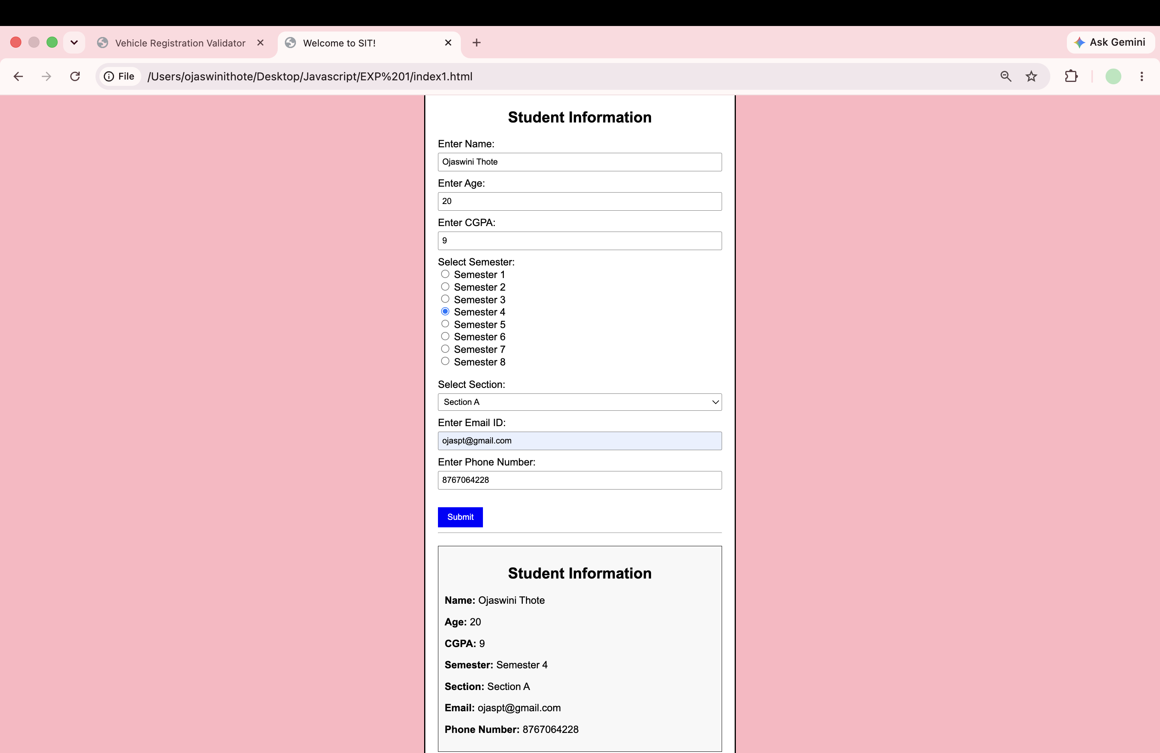
Screenshot 2:
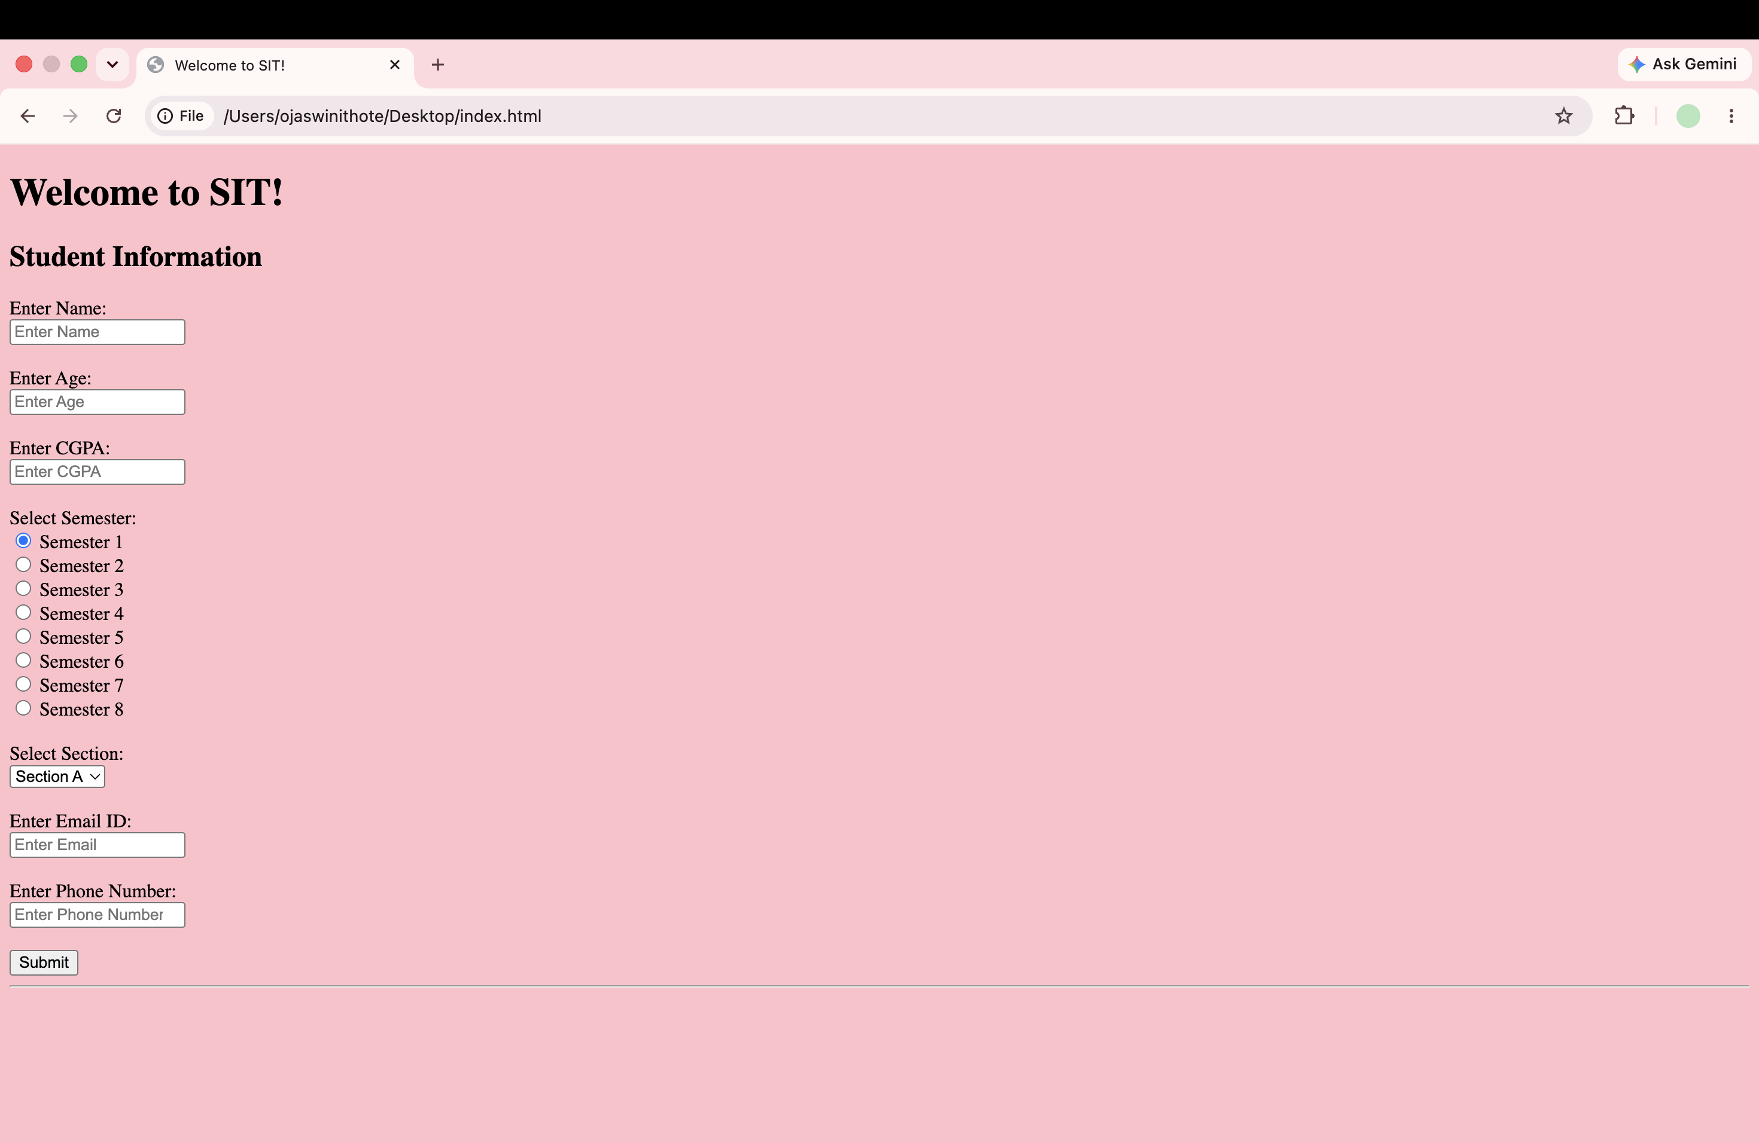

Case Study Title
Student Information Webpage Connected to the Department Homepage using JavaScript
Case Study Screenshot:
https://github.com/user-attachments/assets/27d1ab43-29ef-4da1-948c-a75cd0ad70d2

Case Study Description
This practical demonstrates the implementation of all three methods of including JavaScript within a single web application.
JavaScript Type | Where Used | Purpose
Inline JavaScript | onclick="showWelcome(); greet();" | Calls JavaScript functions when the button is clicked
Internal JavaScript | <script> block inside website.html | Validates input and dynamically generates the student information table
External JavaScript | script.js | Displays a welcome alert and demonstrates console methods

Output Summary
- Department homepage opens successfully.
- Navigation to the student information page works correctly.
- Student details are displayed dynamically after form submission.
- Alert message appears using external JavaScript.
- Console methods execute successfully.
- Input validation prevents empty submissions.

Screenshot
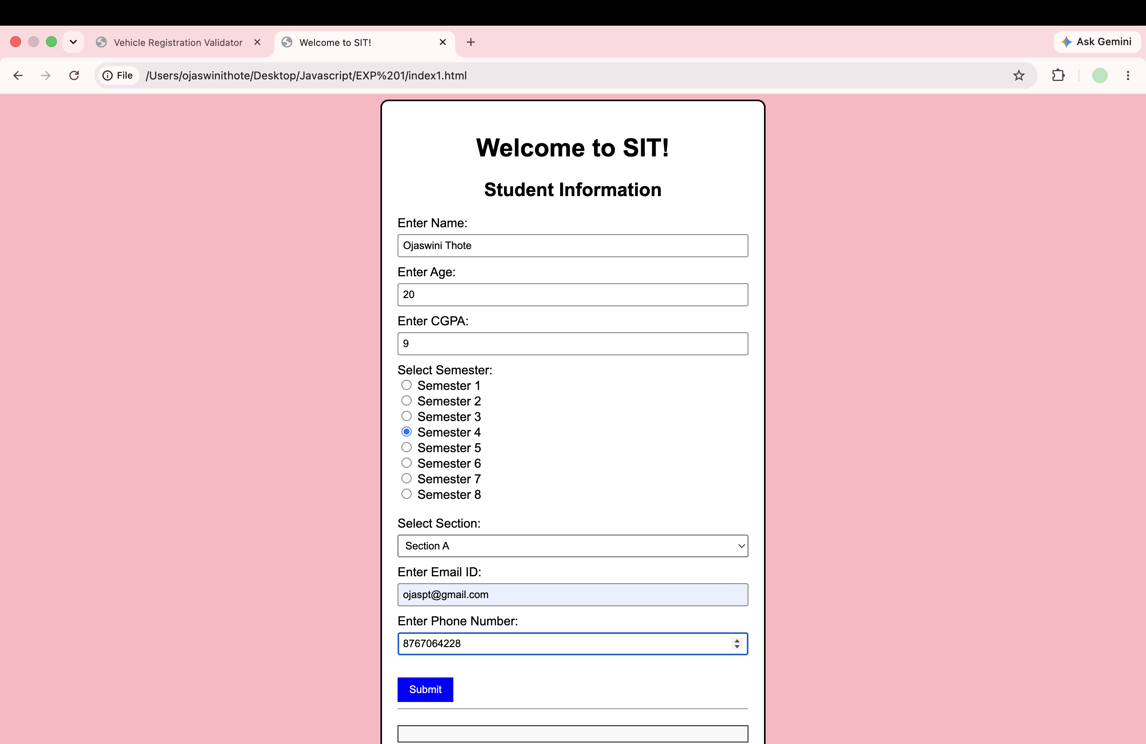

Result / Conclusion
The experiment was completed successfully. The implementation demonstrated the use of Inline, Internal, and External JavaScript within a single web application. Various console methods including console.log(), console.info(), console.warn(), console.error(), console.table(), console.time(), and console.timeEnd() were successfully executed. The project effectively showcases JavaScript event handling, form validation, DOM manipulation, and dynamic content generation through a Student Information Webpage connected to the Department Homepage.

